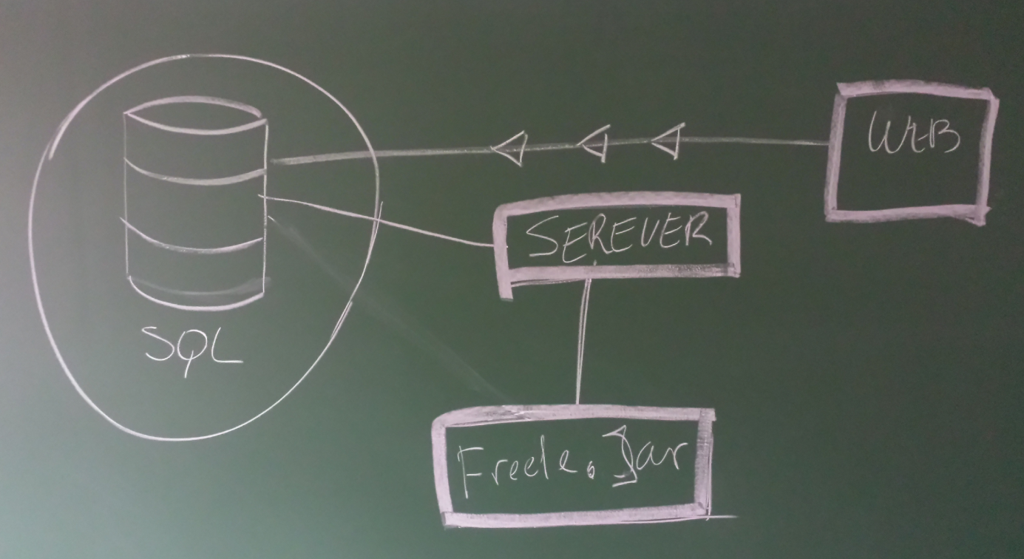

Here’s a picture of how we think the system will be. We have a web-site ([www.freele.org](http://www.freele.org)). Here users can download the program and register as a user so they can log in. The username and password is saved in a SQL database.

The user starts the freele.jar file and gets a message about to log in. The program is connected to the server. The server is connected to the SQL database and checks if the password and username is correct. If it’s right you will be sent to the chat rom.

In the first chat room the user goes to is a public one where everyone who is signed inn can chat. If you want to chat private with someone you can click on one of the username and it will pop up a new window where you can chat privately.

This is the first stage of the project, after everything is working with the chat we will add encryption and decryption and a few other function for the user.